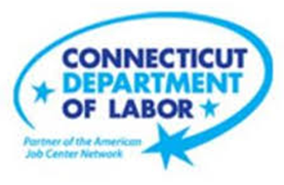

**NEW WEEKLY JOB POSTINGS FROM   
HELP WANTED ONLINE  
Office of Research**

**Week Ending January 21st, 2023: Weekly New Ads Shift Back Towards Four-Week Average.**WETHERSFIELD, January 27th, 2022 – During the week ending January 21st, there were 6,637 new postings, down 2,491 new ads from a week ago. This decline follows a 3,137 ad increase during the week ending January 14th. Though down from a week ago, total ads remain up from earlier weekly levels of 5,991 (week ending Jan. 7th) and 3,726 (week ending Dec. 31st). The graph below illustrates the large shifts in ad counts experienced in January and December. Total ads went from a two-year low to a seven-month high over a two-week span. These state-level swings echo nationwide shifts. The largest statewide industry drops occurred in Health Care & Social Assistance (-691 new ads), Retail Trade   
(-317 new ads), and Manufacturing (-232 new ads). Employers with the largest decreases over the week include   
Yale-New Haven Health System (-207 new ads), Hartford Healthcare (-87 new ads), and Wheeler Clinic (-77 new ads). The occupations with the largest over-the-week decrease are Retail Salespersons (-161 new ads), Registered Nurses   
(-130 new ads), and Supervisors of Retail Sales Workers (-61 new ads). Though down from last week, the weekly new ad total of 6,637 new ads for the week ending January 21st is 4% above the most recent four-week average of 6,385 new ads per week.  
  
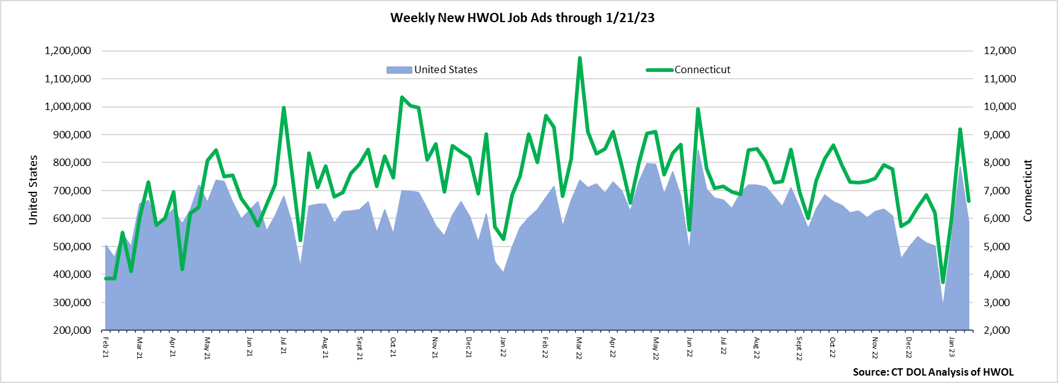  
**Industries** with the most new postings include Health Care & Social Assistance, Manufacturing, and Finance & Insurance.

**Occupations** with the most new postings include Registered Nurses, Retail Salespersons, and Wholesale & Manufacturing Sales Representatives.

**Employers** with the most new postings include Child Guidance Center of Southern Connecticut, Trinity Health, and Hartford Healthcare.

**The three industries with the most new job postings were:**

* **Health Care & Social Assistance** (1,609 new postings, -30% over the week)
* **Manufacturing** (561 new postings, -29% over the week)
* **Finance & Insurance** (560 new postings, -17% over the week)

   
 During the week ending January 21st, 2023, The 2,491 total decline is the net result of a combined 2,671 decrease among 18 industries and a combined 180 ad increase among three industries. The industries that declined over the week fell by between 11% and 64% while the three increasing industries grew by between 15% and 50%. Health Care & Social Assistance had the largest decrease, down 691 new ads and Educational Services had the largest increase, up 167 new ads. The largest employer decrease within Health Care & Social Assistance occurred at Yale-New Haven Health System (-207 new ads) and the largest employer increase within Educational Services occurred at Stamford Public Schools (+57 new ads).  
  
 For more information on total job ads by industry for Connecticut and its labor market areas, see the monthly report available here: <https://www1.ctdol.state.ct.us/lmi/hwol.asp>

**New Job Postings by Occupation** 

**The occupations with the most new postings were:**

* Registered Nurses (420 new postings, -24% over the week)
* Retail Salespersons (150 new postings, -52% over the week)
* Wholesale & Manufacturing Sales Representatives (149 new postings, -20% over the week)

**Employers with the Most New Job Postings**  Employers with the most new job postings during the week were mostly within Health Care & Social Assistance, Education, and Finance & Insurance. The 25 employers shown above account for 18 percent of all new ads. Fifteen employers in the top 25 increased over the week, one was unchanged, and nine decreased. Among the five employers with the most ads, the first four were all within Healthcare & Social Assistance, and Registered Nurses was the most common occupation within those employers. The fifth employer with the most ads was Raytheon and Architectural & Engineering Managers was the occupation at that employer with the most ads.  
  
**What is HWOL?**The **Conference Board Help Wanted Online**® Data Series (HWOL) measures the number of new, first-time Online job postings and jobs reposted from the previous month for over 16,000 Internet job boards, corporate boards, and smaller job sites that serve niche markets and smaller geographic areas. To view more HWOL data, go to: <https://www1.ctdol.state.ct.us/lmi/hwol.asp>